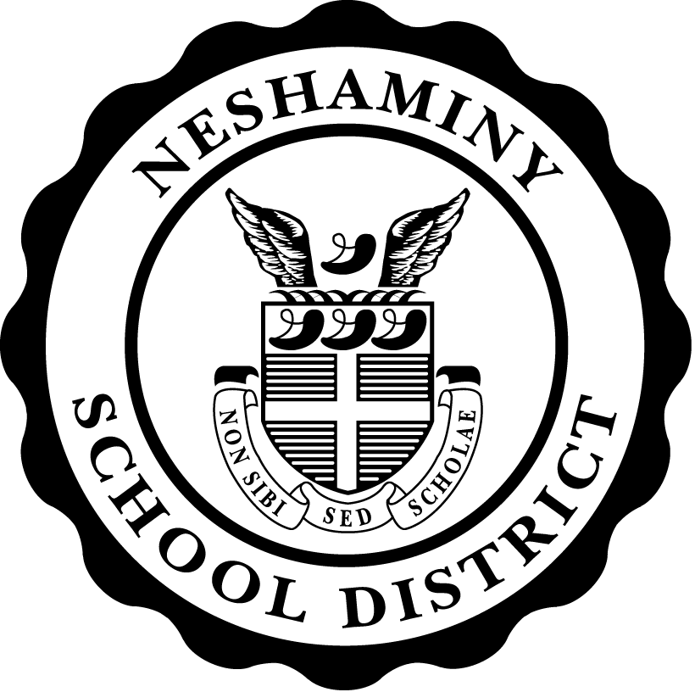
SECTION: 522

TITLE: STUDENT WELLNESS

NESHAMINY SCHOOL
DISTRICT
1 | I. PURPOSE | Neshaminy School District recognizes that student wellness and proper | 1
2 |  | nutrition are related to students’ physical well-being, growth, development | 2
3 |  | and readiness to learn. The Board of School Directors (hereinafter referred to | 3
4 |  | as “the Board”) is committed to providing a school environment that promotes | 4
5 |  | student wellness, proper nutrition, nutrition education, and regular physical | 5
6 |  | activity as part of the total learning experience. In a healthy school | 6
7 |  | environment, students will learn about and participate in positive dietary | 7
8 |  | and lifestyle practices that can improve student achievement and overall | 8
9 |  | health status. | 9
10 |  |  | 10
11 | II. AUTHORITY | To ensure the health and well-being of all students, the Board establishes that | 11
12 | P.L. 108-265 | the District shall provide to students: | 12
13 | Sec. 204 | - A comprehensive nutrition program consistent with federal and state | 13
14 |  | requirements | 14
15 |  | - Access at reasonable cost to foods and beverages that meet established | 15
16 |  | nutritional guidelines. | 16
17 |  | - Physical education courses and opportunities for developmentally | 17
18 |  | appropriate physical activity during the school day. | 18
19 |  | - Curriculum and programs for grades K-12 that are designed to educate | 19
20 |  | students about proper nutrition and the need for lifelong physical activity, | 20
21 |  | to meet or exceed State Board of Education curriculum regulations and | 21
22 |  | academic standards. | 22
23 |  |  | 23
24 | III. DELEGATION | The Superintendent or designee shall be responsible to monitor District | 24
25 | OF | schools, programs, and curriculum to ensure compliance with this policy, | 25
26 | RESPONSIBILITY | related policies, established guidelines and/or administrative regulations. | 26
27 | POL. 808 |  | 27
28 |  | The Superintendent or designee shall report to the Board annually on the | 28
29 |  | District’s compliance with laws and policies related to student wellness. The | 29
30 |  | report may include: | 30
31 |  | - Assessment of school environment regarding student wellness issues. | 31
32 |  | - Evaluation of food services program. | 32
33 |  | - Review of all foods and beverages sold in schools for compliance with | 33
34 |  | established nutrition guidelines | 34

1 |  | POLICY 522 (cont’d) | 1
2 |  | - Listing of activities and programs conducted to promote nutrition and | 2
3 |  | physical activity. | 3
4 |  | - Recommendations for policy and/or program revisions. | 4
5 |  | - Feedback received from District staff, students, parents/guardians, | 5
6 |  | community members and Wellness Committee. | 6
7 |  | - Assurance that District guidelines for reimbursable meals are not less | 7
8 |  | restrictive than regulations and guidelines issued for schools in accordance | 8
9 |  | with federal law. | 9
10 |  |  | 10
11 |  | Wellness Committee | 11
12 |  | The District will establish a Wellness Committee. This Committee will be | 12
13 |  | comprised of the current members of the District Health and Safety | 13
14 |  | Committee as well as a School Board member, District Food Services | 14
15 |  | representative, parent/guardian, student, member of the public, and Lead | 15
16 |  | Teacher of Family & Consumer Sciences. | 16
17 |  |  | 17
18 |  | The Wellness Committee shall serve as an advisory committee regarding | 18
19 |  | student physical activity and nutrition issues. The Committee shall make | 19
20 |  | recommendations for policy changes to promote student wellness, as | 20
21 |  | necessary. The Wellness Committee may: | 21
22 |  | - examine related research and laws | 22
23 |  | - assess student needs and current environment | 23
24 |  | - review existing Board policies and administrative regulations | 24
25 |  |  | 25
26 |  | The Wellness Committee shall convene annually to review the District’s | 26
27 |  | established goals as related to the Wellness Policy and to determine if these | 27
28 |  | goals are being met. Each building principal shall provide a written report | 28
29 |  | to the Committee regarding compliance in his/her school prior to this | 29
30 |  | meeting. A report of the Committee’s findings will be submitted to the | 30
31 |  | Superintendent or his/her designee. | 31
32 |  |  | 32
33 |  | Nutrition Education | 33
34 |  | The goal of nutrition education is to teach, encourage, support, and monitor | 34
35 |  | healthy eating by students. Promoting student health and nutrition enhances | 35
36 |  | readiness for learning and increases student achievement. | 36
37 |  |  | 37
38 |  | Nutrition education will be provided within the sequential, comprehensive | 38
39 |  | health education program in accordance with State Board of Education | 39
40 |  | curriculum regulations and the academic standards of Health, Safety and | 40
41 |  | Physical Education, as well as Family and Consumer Sciences. | 41
42 |  |  | 42
43 |  | Consistent nutrition messages shall be disseminated throughout the District, | 43
44 |  | schools, classrooms, cafeterias, homes, community and media. | 44

1 |  | POLICY 522 (cont’d) | 1
2 |  | Physical Activity | 2
3 |  | The District will embrace physical activity as a personal behavior to improve | 3
4 |  | overall health, academic performance, and to decrease childhood obesity. | 4
5 |  | The District will strive to increase the amount of time all students are | 5
6 |  | physically active each day. | 6
7 |  |  | 7
8 |  | District schools shall contribute to the effort to provide students with | 8
9 |  | opportunities to accumulate at least sixty (60) minutes of physical activity | 9
10 |  | per day. That time will include physical activity outside the school | 10
11 |  | environment, such as outdoor play at home, sports, and other activities. | 11
12 |  |  | 12
13 |  | Physical activity opportunities shall be provided to meet the needs and | 13
14 |  | interests of all students, in addition to planned physical education. Examples | 14
15 |  | include, but are not limited to: recess, lunch, intramural clubs, interscholastic | 15
16 |  | activities, and other before and after school activities. | 16
17 |  |  | 17
18 |  | District schools shall partner with parents/guardians and community | 18
19 |  | members to institute programs that support physical activity. | 19
20 |  |  | 20
21 |  | Physical Education | 21
22 |  | A comprehensive physical education course of study shall be delivered to all | 22
23 |  | students. This course of study will focus on providing students with skills, | 23
24 |  | knowledge and confidence so that they may become and remain physically | 24
25 |  | active throughout their lifetime. | 25
26 |  |  | 26
27 |  | Adequate amounts of planned instruction shall be provided in order for | 27
28 |  | students to achieve the proficient level for the Health, Safety and Physical | 28
29 |  | education academic standards. | 29
30 |  |  | 30
31 |  | Other School Based Activities | 31
32 |  | Goals of the Student Wellness Policy shall be considered in planning all school | 32
33 |  | based activities. | 33
34 |  |  | 34
35 |  | The District will provide information about grant opportunities that relate to | 35
36 |  | nutrition and physical activity to each building to facilitate equitable funding | 36
37 |  | in all schools. | 37
38 |  |  | 38
39 |  | Fundraising projects should be supportive of healthy eating and student | 39
40 |  | wellness. | 40
41 |  |  | 41
42 |  | All Neshaminy employees, students, parents/guardians, and community | 42
43 |  | members shall be encouraged to serve as positive role models. This goal can | 43
44 |  | be accomplished through District programs, communications and outreach | 44
1 |  | POLICY 522 (cont’d) | 1
2 |  | efforts. | 2
3 |  |  | 3
4 |  | The District will provide a Body Mass Index Percentile assessment for our | 4
5 |  | student community and raise community awareness of proper nutrition and | 5
6 |  | physical activity. | 6
7 |  |  | 7
8 |  | The District will implement and maintain a link on the District website to | 8
9 |  | provide information and updates about physical activity and nutrition related | 9
10 |  | topics. | 10
11 |  |  | 11
12 |  | Each building shall be encouraged to register as part of the Pennsylvania | 12
13 |  | Advocates for Nutrition and Physical Activity, Keystone Healthy Schools | 13
14 |  | Zones program. | 14
15 |  |  | 15
16 |  | Nutrition Guidelines | 16
17 |  | All foods available in District schools during the school day shall be offered to | 17
18 |  | students with consideration to promote student health and to reduce | 18
19 |  | childhood obesity. | 19
20 |  |  | 20
21 |  | Foods provided through the National School Lunch or School Breakfast | 21
22 |  | Programs shall comply with federal nutrition standards under the School | 22
23 |  | Meals Initiative. | 23
24 |  |  | 24
25 |  | Competitive foods are defined as foods offered at school other than through | 25
26 |  | the National School Lunch or School Breakfast Programs and include | 26
27 |  | a la carte foods, snacks and beverages; vending food, snacks and beverages; | 27
28 |  | school store food, snacks and beverages; fundraisers; classroom parties; | 28
29 |  | holiday celebrations; and food from home. | 29
30 |  |  | 30
31 |  | The District will make every reasonable effort to offer competitive foods that | 31
32 |  | comply with the Nutritional Standards for Competitive Foods in | 32
33 |  | Pennsylvania. The nutritional standards shall be implemented as a one year | 33
34 |  | plan. | 34
35 |  | - District schools shall provide adequate space for eating and serving school | 35
36 |  | meals. | 36
37 |  | - Students shall be provided a clean and safe meal environment. | 37
38 |  | - Students shall be provided adequate time to eat. | 38
39 |  | - Students shall have access to hand washing or sanitizing before meals and | 39
40 |  | snacks. | 40
41 |  | - Staff development shall be provided for District nutrition personnel. | 41
42 |  | - Access to the food service operation shall be limited to authorized staff. | 42
43 |  | - Nutrition content of school meals shall be available to students and | 43
44 |  | parents/guardians. | 44
1 |  | POLICY 522 (cont’d) | 1
2 |  | - Students and parents/guardians may be involved in menu selections | 2
3 |  | through various means. | 3
4 |  |  | 4
5 |  | Safe Routes to School | 5
6 |  | A task force of key District and community individuals shall be assembled to | 6
7 |  | explore the Safe Routes to Schools initiative. | 7
8 |  |  | 8
9 |  |  | 9
10 |  |  | 10
11 |  |  | 11
12 |  |  | 12
13 |  |  | 13
14 |  |  | 14
15 |  |  | 15
16 |  |  | 16
17 |  |  | 17
18 |  |  | 18
19 |  |  | 19
20 |  |  | 20
21 |  |  | 21
22 |  |  | 22
23 |  |  | 23
24 |  |  | 24
25 |  |  | 25
26 |  |  | 26
27 |  |  | 27
28 |  |  | 28
29 |  |  | 29
30 |  |  | 30
31 |  |  | 31
32 |  |  | 32
33 |  |  | 33
34 |  |  | 34
35 |  |  | 35
36 |  |  | 36
37 | Approved: 6/20/06 |  | 37
38 | JR/sab |  | 38
39 |  |  | 39
40 |  |  | 40
41 |  |  | 41
42 |  |  | 42
43 |  |  | 43
44 |  |  | 44

